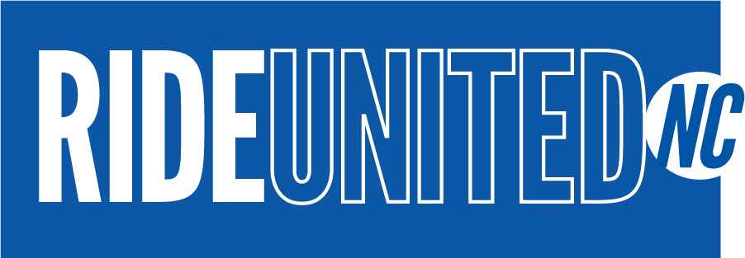
FOR IMMEDIATE RELEASE
Contact: Melissa Reid
United Way of Cumberland County
melissareid@unitedway-cc.org
(910) 483-1179 ext. 228
Underserved Communities in North Carolina Can Now Call
1-844-771-RIDE For Access To Free Roundtrip Transportation To COVID-19 Vaccine Appointments

Provided by RIDE UNITED NC, the free service supports communities of color, seniors, and uninsured individuals across North Carolina.

Fayetteville, NC — April 20, 2021 — Despite the increasing availability of the COVID-19 vaccine in North Carolina, transportation access continues to be a barrier for underserved communities statewide. RIDE UNITED NC announced today that its call center is now available to support low-income North Carolina residents needing roundtrip transportation to COVID-19 vaccine appointments. Eligible individuals can call 1-844-771-RIDE starting today.

The statewide initiative was launched last month by United Way of Cumberland County and United Way of the Greater Triangle in partnership with Lyft, Blue Cross and Blue Shield of North Carolina (Blue Cross NC), and North Carolina Department of Transportation (NCDOT), in support of the North Carolina COVID-19 Public Health Coalition.

The call center has the capacity to support 1,500 calls per day for eligible individuals who do not have access to the Lyft app, those without bank accounts, and seniors. It will also work with NCDOT to supplement transportation needs in other communities. The call center is/has:

- Available Monday through Friday, 8 am to 8 pm
- Bi-lingual capabilities
- Open to those who are age 55+, uninsured, unbanked, and/or members of households considered low-income by the federal definition

The call center is made possible with support from Mako Documents, Pillar Consulting, and Wilcox Distributions. The entire RIDE UNITED NC program is made possible by investments totaling more than $925,000 from Bank of America, Blue Cross NC, Blue Cross NC Foundation, Coastal Credit Union, Duke Energy, and Duke University and Duke Health. These donations support the North Carolina COVID-19 Public Health Coalition and will help provide rides statewide, including in Duke’s home county of Durham.

“Free transportation services are essential for North Carolina to meet its goal of providing equitable access to COVID-19 vaccines and getting ahead of the pandemic,” said Secretary Mandy Cohen. “We very much value the partnership and generosity of everyone who is contributing to RIDE UNITED NC.”

RIDE UNITED NC also supplements existing efforts by the North Carolina Department of Health and Human Services (NCDHHS), NCDOT, and local transit agencies to provide public transportation services to vaccination sites.
Pillar Consulting, founded by epidemiologist Dr. Bahby Banks — along with public support from NCDHHS and Secretary Mandy Cohen — will also provide key community health literacy sessions to support North Carolinians in making informed decisions regarding vaccine uptake.
“We are honored to support RIDE UNITED NC by helping to bridge health literacy gaps related to COVID-19 prevention and vaccine education. This pandemic has shone a bright light on the impact of deeply rooted inequities on the most vulnerable in our state; it has also demonstrated the necessity of clarity and creativity in health communication,” said Dr. Banks. “These health literacy sessions will serve as a means to engage and educate North Carolinians so that they can make the best decisions for their health.”

Pillar Consulting also has the “Not A Host” (or N.A.H.) campaign that has leveraged digital and community engagement to offer culturally engaging and fact-based information about COVID-19 and vaccines for the past year.

Wilcox Distributions, which was founded by former NBA player and North Carolina native Chris Wilcox, will support strategic marketing and communications to North Carolina’s rural and underserved communities.

“My combined NBA and entrepreneurial experiences allow me to do what I’m most passionate about. I am an advocate for those who cannot advocate for themselves. RIDE UNITED NC is a must-do, and well-needed initiative that aligns perfectly with my company’s mission, and my purpose and passion in life,” said Wilcox. I am truly honored to be a part of the RIDE UNITED NC team.”

In addition to the public call center, United Way has also partnered with the North Carolina Community Action Association (NCCAA) and the NC Department of Transportation to identify nonprofits that serve communities of color, seniors, and the underinsured. These organizations will help educate individuals about the vaccination process and provide ride codes that can be used to access transportation to already scheduled appointments. Regional United Ways also involved in supporting RIDE UNITED NC’s efforts include United Way of Asheville and Buncombe County, United Way of the Cape Fear Area, United Way of Central Carolinas, United Way of Onslow County, and United Way of Pitt County.
“North Carolina has a significant number of older adults, low-income individuals and others who may be at higher risk of contracting the virus,” said Sharon C. Goodson, Executive Director of the North Carolina Community Action Association. “Many of these people do not drive, aren’t located near public transportation and live in rural communities with limited access to vaccination sites. We are pleased to partner with United Way to provide transportation to help make vaccinations more accessible to our most vulnerable populations.”
For more information about this initiative, visit the RIDE UNITED NC webpage.

About United Way of Cumberland County:
United Way improves lives by mobilizing the caring power of communities around the world to advance the common good. United Way of Cumberland County strives to advance the common good by focusing on the building blocks for a good life: education, financial stability, health and critical basic needs. At United Way, we recognize that lasting changes are achieved by addressing the underlying causes of problems. United Way partners with other nonprofit agencies to improve lives right here in Cumberland County. Give. Advocate. Volunteer. LIVE UNITED. To learn more, visit www.unitedway-cc.org.

About Pillar Consulting:
Pillar Consulting is a global consulting firm specializing in diversity, equity and inclusion. Our consultants work with partners in grassroots, community-based, government, academic and corporate organizations to provide consultation on their health communication efforts. Our experience in rural and urban areas position us uniquely to engage leaders in strategic thought around health literacy, community engagement and advocacy. Their recent health literacy effort, Not A Host (or N.A.H.) was made possible through initial support from the Maya Angelou Center for Health Equity at Wake Forest University and Facebook Small Business Grants Program. For more information about Not A Host or Pillar Consulting, visit www.pillarconsultingrtp.com.

About Wilcox Distributions:
Wilcox Distribution LLC is a Raleigh-based distribution center with sub-distributor teams located throughout North America and the Caribbean. This distribution company was birthed from the COVID-19 pandemic and created to provide health, wholeness, medical resources, and access for all people, especially those who are aging and in underserved minority groups, such as Native Americans, Hispanics, and Blacks. By intentional design, Wilcox Distribution provides best-in-class medicines and supplies to unserved areas that need them the most. Wilcox Distribution LLC is a trusted, leading wholesale distributor with an extensive inventory of high-quality PPE products (FDA- and CE-registered gloves, gowns, medical scrubs, safety masks, medical equipment, and drug-screening tests), plus cleaning and sanitizing agents and solutions. In September 2020, Wilcox Distribution was awarded primary distribution rights to the world’s only medical device proven by the FDA to kill all airborne pathogens, including COVID-SARS, at a rate of 99.99%, instantaneously and in one pass. IVP Biodefense Indoor Air Filtration System uses innovative heat technologies in a variety of sizes to deliver virus-killing solutions to both residential and commercial/industrial spaces. To learn more, visit www.wilcoxdistributionco.com.

About the North Carolina Community Action Association:
The North Carolina Community Action Association is an anti-poverty member organization that advocates on behalf of the needs of vulnerable families through its statewide network of 34 community action agencies (CAAs) serving all 100 counties. Founded in 1965, we offer training, technical assistance, and other resources to aid our members in fighting poverty in their local communities. Our goal is to empower agencies to help families and communities thrive. For more information about the North Carolina Community Action Association, please visit our website at www.nccaa.net.

About Mako Documents:
Mako Documents organizes, stores, scans and shreds your documents. Never misplace another file. Mako Documents can locate any file in minutes using our proprietary software and tracking systems. Mako Documents stores your documents. Keep your business 100% HIPAA Compliant. Your documents are locked, secured and barcoded in our HIPAA compliant warehouse. Mako Documents scans documents. Digitize your files for instant remote access. Secure, password-protected file retrieval anytime, anyplace. Shred. You want it gone? It’s gone permanently. Shred trucks will destroy your documents ON SITE and give you a certificate of destruction. Call Carrie Peele 919-606-2100 at Mako Documents, she will help you get it done!
About Lyft:
Lyft was founded in 2012 and is one of the largest transportation networks in the United States and Canada. As the world shifts away from car ownership to transportation-as-a-service, Lyft is at the forefront of this massive societal change. Our transportation network brings together rideshare, bikes, scooters, car rentals and transit all in one app. We are singularly driven by our mission: to improve people’s lives with the world’s best transportation.

