__________________________________________________________________________________________________
“Days of Caring”
Every Tuesday in May
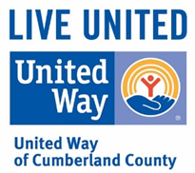
Come support United Way as we raise money to benefit
education, financial literacy, critical basic needs
and health in Cumberland County.
4611 Ramsey Street
(this location only)
Remember to mention UNITED WAY when you order.

