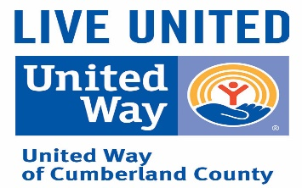
UNITED WAY of CUMBERLAND COUNTY
2020 CAMPAIGN LOG

COMPANY/DEPT:_____________________________ DATE: _________________________________
ADDRESS: ___________________________________ TOTAL # OF EMPLOYEES ON PAYROLL:________
CEO/DEPT HEAD: _____________________________ TOTAL # OF PLEDGES RECEIVED:_____________
NAME OF CONTRIBUTOR | TOTAL AMOUNT PLEDGED | AMOUNT PAID | BALANCE |  | PAYROLL DEDUCTION | CASH OR CHECK | CREDIT CARD
TOTALS

