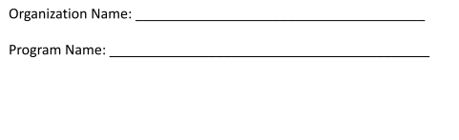
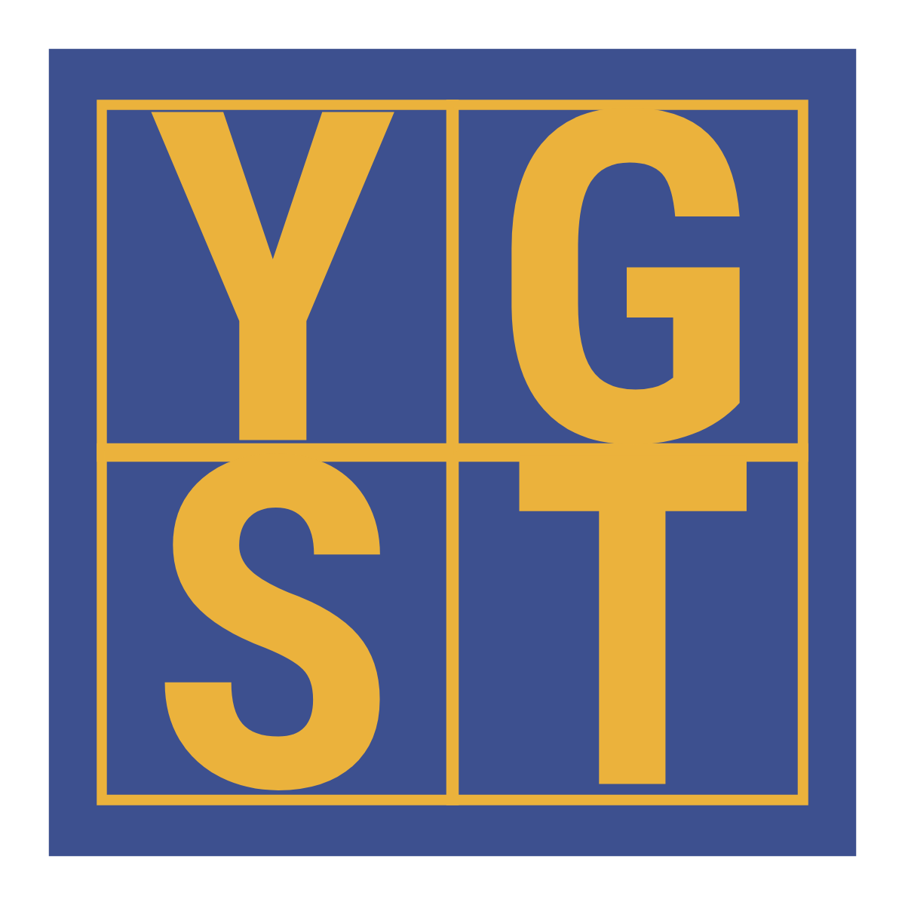


PROGRAM BUDGET REPORT FORM

PROGRAM SUPPORT / REVENUE

Note: You may add, modify, or remove line items as needed to accurately reflect your program’s support and revenue.

Line No. | SECTION 1  Program SUPPORT/REVENUE  Line Items | Program Funding Received from All Sources  FY 2025/2026 | Proposed Program Funding to be Received from All Sources  FY 2026/2027
1 | United Way of Cumberland County
2 | Youth Growth Stock Trust
3 | Grants - City/County
4 | Grants - Federal/State
5 | Foundations
6 | Contributions
7 | Fundraising/Special Events
8 | Program Service Fees charged to participants
9 | Total Support/Revenue

PROGRAM BUDGET REPORT FORM Exenses

-

PROGRAM EXPENSES

Note: You may add, modify, or remove line items as needed to accurately reflect your program’s expenses.

Line No. | SECTION 2  Program EXPENSES  Line Items | All Program Expenses Supported by ALL Sources  FY 2025/2026 | All Program Expenses Supported by YGST  Funding  FY 2026/2027
10 | Salaries / Positions (Please list)
11 | Program Supplies (Please list)
12 | Telephone
13 | Postage
14 | Program Related Marketing
15 | Transportation / Travel
16 | Equipment / Software Purchase
17 | Assistance to Individuals (Scholarships, Meals, etc. Please list)
18 | Occupancy (Rent, etc.)
19 | Awards
20 | Total Expenses

