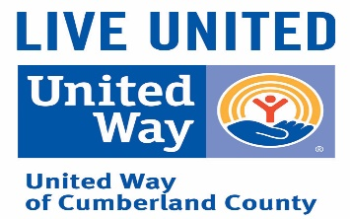

***UNITED WAY of CUMBERLAND COUNTY***

***2022 CAMPAIGN LOG***

COMPANY/DEPT:_____________________________ DATE: _________________________________

ADDRESS: ___________________________________ TOTAL # OF EMPLOYEES ON PAYROLL:________

CEO/DEPT HEAD: _____________________________ TOTAL # OF PLEDGES RECEIVED:_____________

PAYROLL FREQUENCY ___WEEKLY ___BIWEEKLY ___MONTHLY PARTICIPATION %:__________

|  |  |  |  |  |  |  |  |
| --- | --- | --- | --- | --- | --- | --- | --- |
|  | | | |  | METHOD OF PAYMENT | | |
| NAME OF CONTRIBUTOR | TOTAL AMOUNT PLEDGED | AMOUNT INVOICED/PAID | BALANCE |  | PAYROLL DEDUCTION | CASH OR CHECK | CREDIT CARD |
|  |  |  |  |  |  |  |  |
|  |  |  |  |  |  |  |  |
|  |  |  |  |  |  |  |  |
|  |  |  |  |  |  |  |  |
|  |  |  |  |  |  |  |  |
|  |  |  |  |  |  |  |  |
|  |  |  |  |  |  |  |  |
|  |  |  |  |  |  |  |  |
|  |  |  |  |  |  |  |  |
|  |  |  |  |  |  |  |  |
|  |  |  |  |  |  |  |  |
|  |  |  |  |  |  |  |  |
|  |  |  |  |  |  |  |  |
|  |  |  |  |  |  |  |  |
|  |  |  |  |  |  |  |  |
|  |  |  |  |  |  |  |  |
|  |  |  |  |  |  |  |  |
|  |  |  |  |  |  |  |  |
|  |  |  |  |  |  |  |  |
|  |  |  |  |  |  |  |  |
|  |  |  |  |  |  |  |  |
| TOTALS |  |  |  |  |  |  |  |